First of all an embedded system is that system which has computer hardware with
software embedded in it. An Embedded System is controlled by an internal microprocessor
or microcontroller instead of an external control unit.Think of anything that provides
you with programmable options. Any electronic system that allows users to interact,
provides options for configuring behavior,is an embedded system.

These are some of the basic embedded systems that i found in my daily routine:

Digital Camera
Automated Teller Machine(ATM)
Calculator
Digital Watch
Security Camera
Washing Machine
Smart Phone
Telephone
Traffic Signals
Vending Machines
And list will go on.

Calculator - best real life example of embedded system :-

The calculator is the most common example of an embedded system, I must say.
We all used calculators in our daily life to solve our mathematical problems.
A calculator is the embedded system that was developed very early.
In it we give input from the keyboard, the embedded system performs the gives function like
Add, Subtract etc and displays the result on LCD.
Nowadays, the scientific calculators are used. They have a very high-performance processor
These calculators have the ability to perform the complex mathematical functions.
These calculators can be programmable.It is just because of the embedded system,
that these scientific calculators are advanced in their function as compared to simple calculators

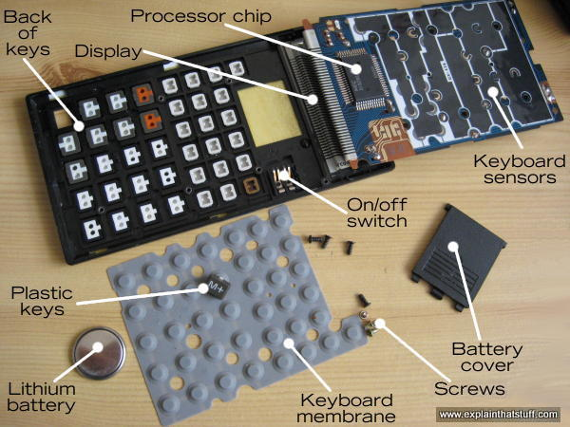
Peripherals:
Input: Keyboard: About 40 tiny plastic keys with a rubber membrane underneath and a touch-sensitive circuit underneath that.

Processor: A microchip that does all the hard work. This does the same job as all the hundreds of gears in an early calculator.

Output: A liquid crystal display (LCD) for showing you the numbers you type in and the results of your calculations.

Power source: A long-life battery (mine has a thin lithium "button" cell that lasts several years). Some calculators also have a solar cell to provide free power in the daylight.

What happens when you press a key?

1.As you press on the hard plastic, you compress the rubber membrane underneath it. This is a kind of a miniature trampoline that has a small rubber button positioned directly underneath each key and a hollow space underneath that. When you press a key, you squash flat the rubber button on the membrane directly underneath it.

2. The rubber button pushes down making an electrical contact between two layers in the keyboard sensor underneath and the keyboard circuit detects this.

3.The processor chip figures out which key you have pressed.

4. A circuit in the processor chip activates the appropriate segments on the display corresponding to the number you've pressed.

5.If you press more numbers, the processor chip will show them up on the display as well—and it will keep doing this until you press one of the operations keys (such as +, −, ×, ÷) to make it do something different. Suppose you press the + key. The calculator will store the number you just entered in a small memory called a register. Then it will wipe the display and wait for you to enter another number. As you enter this second number, the processor chip will display it digit-by-digit as before and store it in another register. Finally, when you hit the = key, the calculator will add the contents of the two registers together and display the result.

References :-
https://en.m.wikipedia.org/wiki/Embedded_system
https://www.slideshare.net/Terminatorsos/the-calculator-71596281
https://www.explainthatstuff.com/calculators.html#inside

